**A**

**L**

**COHOL**

**A**

**N**

**D**

**DRU**

**G**

**TEST**

**ING**

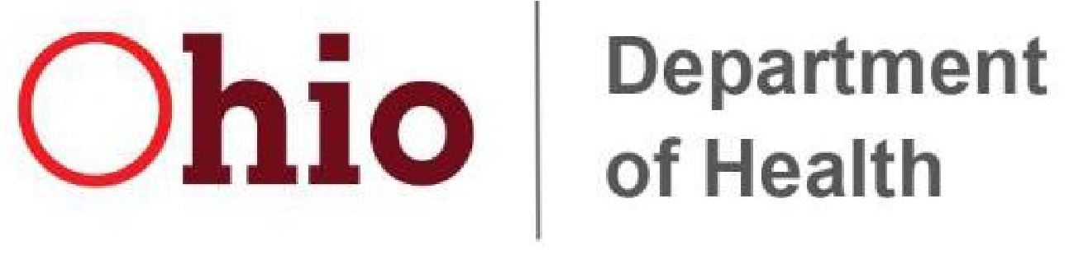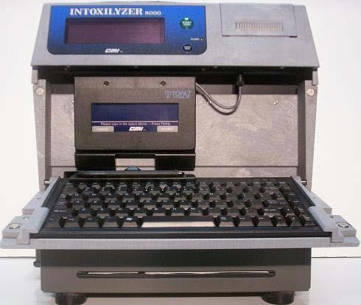

**I**

**n**

**t**

**ox**

**il**

**yz**

**e**

**r**

**8000**

**Operator’s Manual**

**(**

**OH**

**-**

**5)**

**Revised**

**01/2023**

# TABLE OF CONTENTS

Alcohol in the Human Body .............................................. 1-9

Ohio Revised Code ...................................................... 10-16 Ohio Administrative Code ............................................. 17-22

Intoxilyzer 8000 ...................................................................... 22-30

* Front ................................................................................................ 22 • Rear ................................................................................................. 23
* Bottom and Top ............................................................................... 24
* Side ................................................................................................. 25 • Internal Printer ................................................................................. 26 • Signature Pad .................................................................................. 27
* Keyboard ......................................................................................... 28
* 2-D Bar Code Reader ...................................................................... 29 • Magnetic Strip Reader ..................................................................... 30

Intoxilyzer 8000 Operation ...................................................... 31-35

* Theory of Operation ..………………………………………………. 31-32
* Power Up ......................................................................................... 33
* Power Off ......................................................................................... 34 • Not Ready / Ready / Standby / Diagnostics ..................................... 35

Intoxilyzer 8000 Data Entry / Subject Test ............................. 36-40

Intoxilyzer 8000 Escape Sequences ...................................... 41-42

Exception Messages ............................................................... 43-47

Intoxilyzer 8000 Printer ............................................................... 48

Intoxilyzer 8000 Data Transfer ............................................... 49-50

Annual Access Card Proficiency ................................................... 50

Ohio Department of Health

Alcohol & Drug Testing Program

Phone (614) 644-4609

Fax (614) 728-9179 [www.odh.ohio.gov](http://www.odh.ohio.gov/)

badt@odh.ohio.gov

## Alcohol in the Human Body

* Types of Alcohol:
  + Ethyl – Solvent, glues, pharmaceuticals, explosives. o Methyl – Solvent, special fuels (Sterno®), dyes, antifreeze solutions. o Wood. o Isopropyl – Solvent, component for acetone, antiseptics. o Rubbing – Medicinal.
  + Butyl – Solvent, diluent of hydraulic fluids, used to extract drugs.
* Ethanol (ethyl alcohol) is the specific alcohol that is present in alcoholic beverages.
* Ethyl alcohol is not as **toxic** as other alcohols, but all alcohols are toxic. Ethanol may be lethal in excessive quantities.
* Characteristics of ethanol: o Viscosity – Thin. o Color – Colorless (clear).
  + Smell – Slight odor. o Taste – Irritating burning taste, high affinity for moisture.

For the remainder of this text, the term alcohol will denote ethyl alcohol.

* **Acetone**, found in uncontrolled diabetics/diabetic crisis, **closely matches the signs and symptoms of alcohol. The instrument will detect acetone and display as an Interferent Detect.** The instrument will abort the test, beeps, display Interferent Detect, print Interferent Detect. Other substances resembling ethanol may also be seen as an interferent.

### Absorption of Alcohol

* Alcohol can enter the body in several different ways: skin absorption, inhalation, injection, alcohol enema, and **orally (ingestion by drinking)**.
* Absorption through the skin and absorption through inhalation result in very little alcohol being introduced into the body. It is virtually impossible to have any significant concentration build up in the body in these ways.
* Alcohol is absorbed unchanged, not digested, into the blood stream.
* Only a small amount of alcohol will be absorbed through the lining of the mouth. All traces of alcohol will be gone from the mouth within **15 to 20 minutes** after the last drink, thus the **20-minute observation period** before any breath test in Ohio.
* The majority of alcohol is absorbed by the stomach and small intestine.
* Food in the stomach slows the absorption of alcohol.
* **Stomach content is the single greatest factor in the absorption rate of alcohol.**

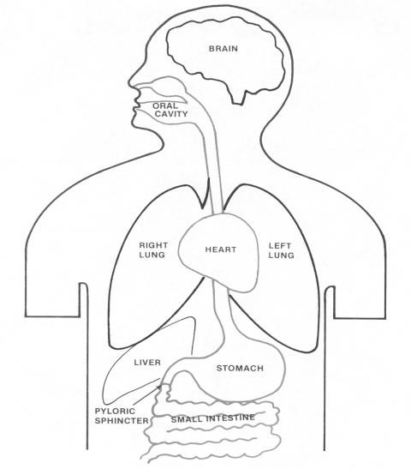

2

5

%

7

5

%

## BAC

* BAC stands for blood alcohol concentration. It is the standard of measurement to determine the amount of alcohol in the body. BAC is the percentage of alcohol in the blood, weight by volume, based on the weight of alcohol (in **grams**) per each **100 milliliters of blood.**
* It was believed for many years that alcohol was a normal constituent of the body. Specific analyses now demonstrate that, if present at all, it is in concentrations much less than 0.001% BAC (not measurable).

**The Route of Alcohol into The Body**

* 1. Mouth and throat 5) Lungs
  2. Stomach and small intestine 6) Heart
  3. Liver 7) Brain and the rest of the
  4. Heart body

### The Mouth

• Only a small amount of alcohol will be absorbed through the lining of the mouth. All traces of alcohol will be gone from the mouth within 15 to 20 minutes after the last drink, thus the 20-minute observation period before any breath test in Ohio.

### The Throat (Esophagus)

• The alcohol spends very little time in the esophagus; there is no measurable absorption.

### The Stomach

* The stomach is the first place where alcohol is noticeably absorbed (not digested) into the blood. Absorption from the stomach is slow. Approximately 20 to 25% of the alcohol taken in will be absorbed through the lining of the stomach. The rate at which alcohol will be absorbed from the stomach depends on: o The contents of the stomach, o The strength of the drink, o The type of mix of drink.
* The contents of the stomach, both in quality and quantity, can slow the absorption rate. The food itself will absorb the alcohol (it will eventually be absorbed into the blood). By slowing down absorption, the peak BAC will be lower than on an empty stomach. Some types of foods delay the absorption rate better than others. Foods like spaghetti and bread will absorb alcohol quite well. Greasy or fatty foods will slow absorption. Absorption begins within one to two minutes of the first drink and will be complete by 90 minutes after the last drink. If the stomach was empty, absorption could be complete 30 minutes after the last drink. Stomach content is the biggest single factor in determining the rate of absorption.
* The absorption rate is optimum at 20% alcohol, which is usually the maximum you can expect in a mixed drink at a bar. Lower concentrations would slow down absorption.
* The type of mix of drink also makes a difference. If there is carbonation present, this speeds up absorption, quicker than with natural juices, water, etc.

### The Small Intestine

• Absorption from the small intestine is rapid, with about 70 to 75% of the alcohol consumed being absorbed through the first seven to nine inches of the small intestine. Alcohol is readily absorbed from the small intestine, with nothing apparently affecting the absorption rate as was possible in the stomach.

### The Liver

* **The liver provides the body's mechanism for changing alcohol into useful chemicals. Unlike other foods, the rate at which alcohol is oxidized does not depend on the energy used by the body, but rather on the amount of working liver.**
* **The working size of the liver, in proportion to the body, is much the same for all people. Therefore, the proportion of alcohol metabolized in the liver each hour is basically the same for everyone.**
* **Approximately 90% of the alcohol will be oxidized by the liver.**
* The elimination rate, to be conservative, is 0.015 g/210L per hour.
* **The only way to sober up is to allow the body to metabolize the alcohol. Exercise, caffeine or other stimulants will not speed up the process. While food in the stomach before drinking will slow the absorption of alcohol, eating after drinking will not affect the metabolism of alcohol.**

### The Heart

• Alcohol has an effect that dilates the blood vessels. The symptoms that demonstrate this effect are: blood-shot eyes, flushed face, and general warm feelings. The result of this effect is an extra load on the heart to pump more blood. However, even in gross intoxication the normal healthy heart shouldn't have any problems handling this extra load.

### The Lungs

• The lungs aerate the blood and will eliminate a certain amount of alcohol vapor from the blood, giving the drinker alcohol breath. The importance of these facts will be discussed in the section on Henry's Law.

### The Heart

• The blood from the lungs returns to the heart and is distributed to the rest of the body.

### The Brain

* Alcohol is a central nervous system depressant at all dosages.
* Although it appears to stimulate when used moderately, alcohol has a depressing effect on a person’s inhibitions. The brain can be likened to a computer that tells the other parts of the body how and when to function.
* As the alcohol slowly depresses the nervous system, everything slows down, becomes disorganized and will eventually result in the total crash of the system.
* The highest functions, such as judgment and self-control, will be affected first, vision problems, and loss of muscular control of the voluntary muscles (slurred speech) next, and finally the involuntary muscles are affected. Involuntary muscles control breathing and the heart.

### Alcohol and Water

• Alcohol has a high affinity for water. Blood will carry alcohol to various tissues and organs of the body and will deposit the alcohol in proportion to their water contents. Brain and muscle tissue have a high-water content, so they receive a substantial share of the distributed alcohol. Fat and bone have very little water content, thus little alcohol is deposited there.

o Body fat = very low alcohol concentration. o Blood/muscle = high alcohol concentration.

### Impairment

* Alcohol acts as a central nervous system (CNS) depressant, which means that it slows down the responses.
* Alcohol has a variety of effects, including cognitive, sensory, and motor. The final effect of impairment is death.
* Impairment is based upon measurable decreases in an individual’s performance of a specific task, such as operating a motor vehicle.
* Intoxication is NOT the same as impairment – intoxication describes a type of observed behavior.
* Alcohol also interacts with other drugs (i.e., combination with other depressants increases impairment).
* If you find impairment and the subject breath test is low or null, consider the possibility that drugs are involved, such as CNS depressants or CNS stimulants, dissociative anesthetics, hallucinogens, narcotic analgesics, inhalants, or cannabis.

### Divided Attention

* Divided attention deals with having to focus on more than one task at the same time. For example, driving tasks that must be completed simultaneously include steering, working the pedals, checking the rear-view mirrors, etc.
* Alcohol-impaired drivers require more time to read a street sign or to recognize and respond to a traffic signal than those who are not impaired.
* Consequently, they look at fewer sources of information and acquire less total information per unit of time.

According to the National Safety Council, ***all people*** are impaired for the ***task*** of operating a motor vehicle at a ***0.080 g/210L*** alcohol concentration.

### Tolerance

* Tolerance is usually defined as the effect which results from the chronic use of a drug when a larger dose is needed to achieve the desired effect.
* In alcohol, tolerance is better described as the effect where the expected changes in behavior or impairment in performance of a specific task are not observed.
* Alcohol tolerance is split into two types: metabolic and functional.
* Metabolic tolerance is the ability of the body to eliminate alcohol more quickly.
* The body has a second system which can aid the liver in metabolizing alcohol. In alcoholics, where large quantities of alcohol are present on a regular basis, this system turns on and the body begins metabolizing alcohol faster.
* Functional tolerance comes from the person being used to the effects of alcohol. Because of this, the person has acquired behaviors to mask their impairment.
* As a result, the person appears less intoxicated than they really are. It is important to remember; however, that their mental and physical capacities are still impaired; they simply have found a way to make this impairment less obvious.

|  |  |
| --- | --- |
| 0.60 | Death occurs |
| 0.50+ | Comatose |
| 0.40 | Fatal dose in some persons |
| 0.27-  0.40 | Unable to stand or walk, vomiting, lapses into sleep |
| 0.18-  0.30 | Mental confusion, slurred speech, staggering |
| 0.18 | Crash involvement increased dramatically (50+ times average) |
| 0.08-  0.10 | Decreasing muscle control and hand coordination |
| 0.08 | Illegal Per Se, all drivers impaired (National Safety Council) |
| 0.06 | Vision focus recovery increases from .1 to .2 seconds |
| 0.05-  0.06 | Fine motor skills impaired (gaze nystagmus may be noticed) |
| 0.05 | AMA Recommendation for per se level |
| 0.04 | DOT limit for CDL |
| 0.04 | Increased crash involvement |
| 0.04 | Decreased night vision, glare recovery, depth perception |
| 0.03-  0.10 | More sociable, loss of attention, judgment & intellect impaired |
| 0.025 | Alcohol content of 150-pound man with one standard drink |
| 0.02 | Impairment begins, DOT screening level |
| 0.01-  0.05 | Drinker appears normal |

### Henry’s Law

* **Henry’s Law is the scientific basis for breath testing.**
* Henry’s Law states:

***The concentration of a volatile substance in the air above a liquid is proportional to the concentration of the volatile substance in the liquid.***

* As applied to breath testing, this means:

***The concentration of alcohol in the breath is proportional to the concentration of alcohol in the blood.***

* This proportion for blood to breath is 2100:1, which means that for every 2100 molecules of alcohol in the blood, there will be one molecule of alcohol in the breath.
* The temperature at which the breath leaves the mouth is 34 degrees Celsius and the ratio between the concentration of alcohol in blood and air with which it is in equilibrium is determined at 34°C.

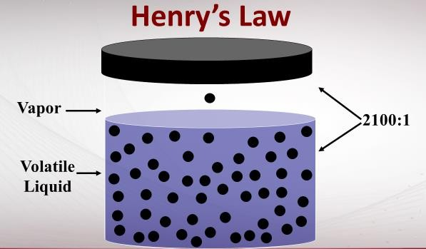

* The exchange of alcohol molecules between the blood and the breath takes place in the *alveoli*, the air sacs deep within the lungs. **When the subject has been requested to provide a breath sample, they are instructed to give a sample of deep lung air, which will closely match the blood to breath ratio** of the alveolar air.

**Breath Test**

* **Deep lung air;** o Most closely approximates blood test result.

o Easy to obtain with instantaneous results.

* **Breath units: grams alcohol per 210 L of breath (g/210 L).**
* Blood to breath ratio: 2100:1.
* Blood units: grams alcohol per 100 ml of blood (g/100 ml).
* Urine: grams alcohol per 100 ml of urine (g/100 ml).

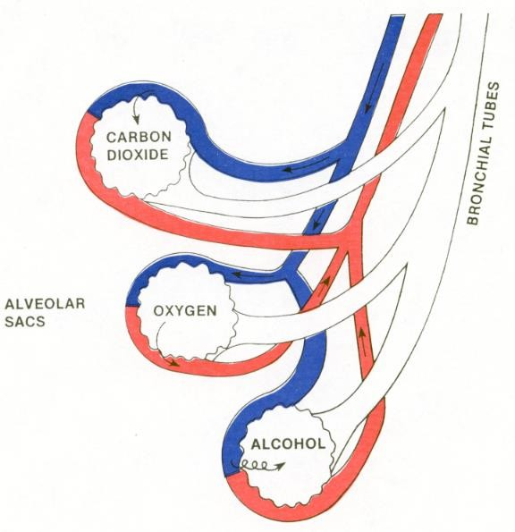

# OHIO REVISED CODE

**THE SECTIONS LISTED ARE ADAPTED FROM THE ORC**

**3701.143 Analyzing blood, urine, breath or other bodily substance to determine alcohol or drug of abuse content.**

For purposes of sections [1547.11](http://codes.ohio.gov/orc/1547.11) , [4511.19](http://codes.ohio.gov/orc/4511.19) , and [4511.194](http://codes.ohio.gov/orc/4511.194) of the Revised Code, the director of health shall determine, or cause to be determined, techniques or methods for chemically analyzing a person's whole blood, blood serum or plasma, urine, breath, or other bodily substance in order to ascertain the amount of alcohol, a drug of abuse, controlled substance, metabolite of a controlled substance, or combination of them in the person's whole blood, blood serum or plasma, urine, breath, or other bodily substance. **The director shall approve satisfactory techniques or methods, ascertain the qualifications of individuals to conduct such analyses, and issue permits to qualified persons authorizing them to perform such analyses.** **Such permits shall be subject to termination or revocation at the discretion of the director.** As used in this section, "drug of abuse" has the same meaning as in section 4506.01 of the Revised Code.

**4511.01 Traffic laws - operation of motor vehicles definitions.**

**(A)** "**Vehicle**" means every device, including a motorized bicycle and an electric bicycle, in, upon, or by which any person or property may be transported or drawn upon a highway.

(HHH) "Operate" means to cause or have caused movement of a vehicle, streetcar, or trackless trolley.

**4511.19 Operating vehicle under the influence of alcohol or drugs - OVI**

**(A) (1) No person shall operate any vehicle, streetcar, or trackless trolley within this state, if, at the time of the operation, any of the following apply:**

1. **The person is under the influence of alcohol, a drug of abuse, or a combination of them.**

**Note: There must be probable cause to make the original contact. To make an OVI arrest you must be able to demonstrate *impairment.* Without impairment, there is no reason to proceed to a chemical test. The (A)(1)(a) is a standalone charge.**

1. The person has a concentration of eight-hundredths of one per cent or more but less than seventeen-hundredths of one per cent by weight per unit volume of alcohol in the person's whole blood.
2. The person has a concentration of ninety-six-thousandths of one per cent or more but less than two hundred four-thousandths of one per cent by weight per unit volume of alcohol in the person's blood serum or plasma.
3. **The person has a concentration of eight-hundredths of one gram or more but less than seventeen-hundredths of one gram by weight of alcohol per two hundred ten liters of the person's breath.**
4. The person has a concentration of eleven-hundredths of one gram or more but less than two hundred thirty-eight-thousandths of one gram by weight of alcohol per one hundred milliliters of the person's urine.

**(h) The person has a concentration of seventeen-hundredths of one gram or more by weight of alcohol per two hundred ten liters of the person's breath.**

(Note: Levels above the listed per se, i.e., .170% BrAC, face elevated penalties.)

**4511.19 (A)(1)(j) –** Addresses drug sections. If you find impairment and the subject alcohol breath test is low, call a DRE or test for alternative substances. ARIDE classes focus on drug impairment and classifications of drugs.

* + CNS Depressants, e.g., barbiturates, Valium, Prozac, Xanax.
  + CNS Stimulants, e.g., cocaine, amphetamines, meth, kaht.
  + Hallucinogens, e.g., LSD, peyote (mescaline), psilocybin.
  + Dissociative Anesthetics, e.g., PCP, Ketamine, certain anti-tussives.
  + Narcotic Analgesics, e.g., morphine, heroin, oxycontin.
  + Inhalants, e.g., gasoline, cleaning fluid, paint, Dust-Off.
  + Cannabis, e.g., marijuana, hashish, Marinol.

(2) No person who, within twenty years of the conduct described in division (A)(2)(a) of this section, previously has been convicted of or pleaded guilty to a violation of this division, a violation of division (A)(1) or (B) of this section, or any other equivalent offense shall do both of the following:

1. Operate any vehicle, streetcar, or trackless trolley within this state while under the influence of alcohol, a drug of abuse, or a combination of them;
2. Subsequent to being arrested for operating the vehicle, streetcar, or trackless trolley as described in division (A)(2)(a) of this section, being asked by a law enforcement officer to submit to a chemical test or tests under section 4511.191 of the Revised Code, and being advised by the officer in accordance with section 4511.192 of the

Revised Code of the consequences of the person’s refusal or submission to the test or tests, refuse to submit to the test or tests.

**(B)** No person under twenty-one years of age shall operate any vehicle, streetcar, or trackless trolley within this state, if, at the time of the operation, any of the following apply:

(3)The person has a concentration of at least two-hundredths of one gram but less than eight-hundredths of one gram by weight of alcohol per two hundred ten liters of the person’s breath.

**(D) (1) (b)** In any criminal prosecution or juvenile court proceeding for a violation of division (A) or (B) of this section or for an equivalent offense that is vehicle-related, **the court may admit evidence on the concentration of alcohol**, drugs of abuse, controlled substances, metabolites of a controlled substance, or a combination of them in the defendant'swhole blood, blood serum or plasma,breath,urine, or other bodily substance at the time of the allegedviolation as shown by chemical analysis **of the substance withdrawn within three hours of the time of the alleged violation.** The three-hour time limit specified in this division regarding the admission of evidence does not extend or affect the two-hour time limit specified in division (A) of section 4511.192 of the Revised Code as the maximum period of time during which a person may consent to a chemical test or tests as described in that section. The court may admit evidence on the concentration of alcohol, drugs of abuse, or a combination of them as described in this division when a person submits to a blood, breath, urine, or other bodily substance test at the request of a law enforcement officer under section 4511.191 of the Revised Code or a blood or urine sample is obtained pursuant to a search warrant. Only a physician, a registered nurse, or a qualified technician, chemist, or phlebotomist shall withdraw a blood sample for the purpose of determining the alcohol, drug, controlled substance, metabolite of a controlled substance, or combination content of the whole blood, blood serum, or blood plasma. This limitation does not apply to the taking of breath or urine specimens. A person authorized to withdraw blood under this division may refuse to withdraw blood under this division, if in that person’s opinion, the physical welfare of the person would be endangered by the withdrawing of blood.

**Such bodily substance shall be analyzed in accordance with methods approved by the director of health by an individual possessing a valid permit. Only a permit holder may analyze the sample**

**(D)(2)** If there was at the time the bodily substance was withdrawn a concentration of **less than** the applicable concentration of **alcohol** specified in divisions (A)(1)(b), (c),

(d), and (e) of this section or less than the applicable concentration of a listed

**controlled substance** or a listed **metabolite of a controlled substance** specified for a violation of division (A)(1)(j) of this section, that fact may be considered with other competent evidence.

A chemical test less than .08% BAC does not have to be reduced to a lesser offense.

(3) **Upon the request of the person who was tested, the results of the chemical test shall be made available to the person or the person's attorney, immediately upon the completion of the chemical test analysis.**

**If the chemical test was obtained pursuant to division (D)(1)(b) of this section, the person tested may have a physician, a registered nurse, or a qualified technician, chemist, or phlebotomist of the person's own choosing administer a chemical test or tests, at the person's expense, in addition to any administered at the request of a law enforcement officer.** If the person was under arrest as described in division (A)(5) of section 4511.191 of the Revised Code, the arresting officer shall advise the person at the time of the arrest that the person may have an **independent chemical test** taken at the person's own expense. If the person was under arrest other than described in division (A)(5) of section 4511.191 of the Revised Code, the form to be read to the person to be tested, as required under section 4511.192 of the Revised Code, shall state that the person may have an independent test performed at the person's expense. The failure or inability to obtain an additional chemical test by a person shall not preclude the admission of evidence relating to the chemical test or tests taken at the request of a law enforcement officer (Note: There is no time limit for this test.)

**(F)** Any qualified person who withdraws blood pursuant to this section is **immune** from criminal and civil liability - unless malpractice.

Protected by law when person is unconscious or incapable of refusing.

**(K)** Division (A)(1)(j) of this section does not apply to a person who operates a vehicle, streetcar, or trackless trolley while the person has a concentration of a listed controlled substance or a listed metabolite of a controlled substance in the person's whole blood, blood serum or plasma, or urine that equals or exceeds the amount specified in that division, if both of the following apply:

1. The person obtained the controlled substance pursuant to a prescription issued by a licensed health professional authorized to prescribe drugs.
2. The person injected, ingested, or inhaled the controlled substance in accordance with the health professional's directions.

(Note: Even if a person is acting within the scope of subsections (1) and (2), this does not give them the right to drive impaired while under the effect of those drugs.) **4511.191 Implied consent.**

**(A)(2)** Any person who **operates** a vehicle, streetcar, or trackless trolley upon a highway or any public or private property used by the public for vehicular travel or parking within this state or who is in **physical control** of a vehicle, streetcar, or trackless trolley shall be deemed to have given consent to a chemical test or tests of the person's whole blood, blood serum or plasma, breath, or urine to determine the **alcohol, drug of abuse, controlled substance, metabolite of a controlled substance**, or combination content of the person's whole blood, blood serum or plasma, breath, or urine.

1. The officer must have reasonable grounds to request the test (probable cause). More than one chemical test may be requested. The law enforcement agency designates which test shall be administered.

1. Any person who is dead or unconscious, or who otherwise is in a condition rendering the person incapable of refusal, shall be deemed to have consented as provided in division (A)(2) of this section, and the test or tests may be administered, subject to sections 313.12 to 313.16 of the Revised Code (See Mitchell V Wisconsin 2019).

**(A) (5) (a)** If a law enforcement officer arrests a person for a violation of division (A) or (B) of section 4511.19 of the Revised Code, section 4511.194 of the Revised Code or a substantially equivalent municipal ordinance, or a municipal OVI ordinance and if the person if convicted would be required to be sentenced under division (G)(1)(c), (d), or (e) of section 4511.19 of the Revised Code, **the law enforcement officer shall request the person to submit, and the person shall submit, to a chemical test or tests of the person's whole blood, blood serum or plasma, breath, or urine for the purpose of determining the alcohol, drug of abuse, controlled substance, metabolite of a controlled substance, or combination content of the person's whole blood, blood serum or plasma, breath, or urine.** A law enforcement officer who makes a request pursuant to this division that a person submit to a chemical test or tests is not required to advise the person of the consequences of submitting to, or refusing to submit to, the test or tests and is not required to give the person the form described in division (B) of section 4511.192 of the Revised Code, but the officer shall advise the person at the time of the arrest that **if the person refuses to take a chemical test the officer may employ whatever reasonable means are necessary to ensure that the person submits to a chemical test of the person's whole blood or blood serum or plasma. The officer shall also advise the person at the time of the arrest that the person may have an independent chemical test taken at the person's own expense.** (Note: This is for two or more OVI convictions in ten years, 5 or more in 20 years or a previous felony OVI conviction.) (**See Birchfield V North Dakota 2016.**)

(b) If a person refuses to submit to a chemical test upon a request made pursuant to division (A)(5)(a) of this section, **the law enforcement officer who made the request may employ whatever reasonable means are necessary to ensure that the person submits to a chemical test** of the person's whole blood or blood serum or plasma. A law enforcement officer who acts pursuant to this division to ensure that a person submits to a chemical test of the person's whole blood or blood serum or plasma is immune from criminal and civil liability based upon a claim for assault and battery or any other claim for the acts, unless the officer so acted with malicious purpose, in bad faith, or in a wanton or reckless manner.

**4511.192 Advice to OVI arrestee.**

**(A)** Except as provided in division (A)(5) of section 4511.191 of the Revised Code, the arresting law enforcement officer shall give advice in accordance with this section to any person under arrest for a violation of division (A) or (B) of section 4511.19 of the Revised Code, section 4511.194 of the Revised Code or a substantially equivalent municipal ordinance, or a municipal OVI ordinance. The officer shall give that advice in a written form that contains the information described in division (B) of this section and shall read the advice to the person. **The form shall contain a statement that the form was shown to the person under arrest and read to the person by the arresting officer. One or more persons shall witness the arresting officer's reading of the form, and the witnesses shall certify to this fact by signing the form.** The person must submit to the chemical test or tests, subsequent to the request of the arresting officer, within two hours of the time of the alleged violation and, if the person does not submit to the test or tests within that two-hour time limit, the failure to submit automatically constitutes a refusal to submit to the test or tests.

**(D)(1)(a)** A refusal or positive test above the per se results in an automatic license suspension. **Initial** appearance will be held within **five days** **after the date of the person’s arrest or the issuance** of the citation.

**(D)(1)(d)** The ALS hearing is limited to:

* 1. An OVI arrest based on probable cause,
  2. The person was advised of the consequences of a positive test or refusal, **(iii)** The person was offered a test,

**(iv)** The person tested positive or refused.

**4511.194 Having physical control of vehicle while under the influence.**

1. As used in this section: (2) "Physical control" means being in the driver's position of the front seat of a vehicle or in the driver's position of a streetcar or trackless trolley and having possession of the vehicle's, streetcar's, or trackless trolley's ignition key or other ignition device.
2. **No person shall be in physical control of a vehicle, streetcar, or trackless trolley if, at the time of the physical control, any of the following apply:**
3. The person is under the influence of alcohol, a drug of abuse, or a combination of them.
4. **The person's** whole blood, blood serum or plasma, **breath**, or urine **contains at least the concentration of alcohol specified in division (A)(1)(b), (c), (d), or (e) of section** [**4511.19**](http://codes.ohio.gov/orc/4511.19) **of the Revised Code.**

# OHIO ADMINISTRATIVE CODE

**Chapter 3701-53 Alcohol Testing**

**3701-53-01 Definitions and record retention periods.**

(A) The purpose of Chapter 3701-53 of the Administrative Code is to clarify and implement the provisions of sections 1547.11 and 4511.19, of the Revised Code. As used in this chapter of the Administrative Code:

(1) “Director” means the director of the Ohio department of health and includes any authorized representative of the director.

(5) “Operator” means a person who holds a valid operator permit under rule 3701-53-10 of the Administrative Code.

1. “Oral fluid” means a type of bodily substance collected from the mouth consisting of saliva and other oral secretions.
2. “Deep lung breath” means breath collected or measured at the end of an exhalation (alveolar air).
3. “Procedure manual” means a document approved by the designated laboratory director that outlines laboratory procedures for techniques listed on the designated laboratory director’s permit.
4. “Traceable to NIST” means the standard was manufactured with equipment calibrated with NIST (national institute of standards and technology) weights or the standard was compared to a NIST traceable certified reference material or equivalent standard from a National Metrology Institute (N. M. I.) with a reciprocal agreement with NIST. Traceability is documented by the certificate(s) of analysis provided by the manufacturer.
5. “Drug of abuse” means any controlled substance as defined in section [3719.01](https://codes.ohio.gov/ohio-revised-code/section-3719.01) of the Revised Code, any harmful intoxicant as defined in section [2925.01](https://codes.ohio.gov/ohio-revised-code/section-2925.01) of the Revised Code, and any dangerous drug as defined in section [4729.01](https://codes.ohio.gov/ohio-revised-code/section-4729.01) of the Revised Code.
6. “Impairing substance” means any substance that when taken into the human body can impair the ability of that person to operate a motor vehicle safely.

(B) Record retention periods.

(1) The results of the breath alcohol tests are to be retained for not less than three years from the test date.

1. The results of certifications and weekly checks for breath alcohol testing instruments are to be retained for not less than three years from the date performed.

1. Records of repairs and maintenance for breath alcohol testing instruments and laboratory instruments are to be retained for not less than three years from the date of service or maintenance.

1. Records may be maintained in electronic or paper format.

**3701-53-02** ’[’**Expression of results.**](http://codes.ohio.gov/oac/3701-53-01)

1. Tests to determine the concentration of alcohol, drugs of abuse, a controlled substance or metabolite of a controlled substance or other impairing substance may be applied to blood, breath, urine, or other bodily substances including oral fluid.

1. Results shall be expressed as equivalent to:
2. Grams by weight of alcohol per one hundred milliliters of whole blood, blood serum or plasma (grams per cent by weight);
3. Grams by weight of alcohol per two hundred ten liters of deep lung breath;
4. Grams by weight of alcohol per one hundred milliliters of urine (grams per cent by weight).
5. Nanograms by weight of a drug of abuse, controlled substance or a metabolite of a controlled substance or other impairing substance per milliliter of blood, urine, oral fluid or other bodily substance.

[**3701-53-03 Breath tests.**](http://codes.ohio.gov/oac/3701-53-02)

(A) The instruments listed in this paragraph are approved as evidential breath testing instruments for use in determining whether a person's breath contains a concentration of alcohol prohibited or defined by sections [4511.19](http://codes.ohio.gov/orc/4511.19) , and/or [1547.11](http://codes.ohio.gov/orc/1547.11) of the Revised Code, or any other equivalent statute or local ordinance prescribing a defined or prohibited breath-alcohol concentration. The approved evidential breath testing instruments are:

1. BAC DataMaster, BAC DataMaster K, BAC DataMaster cdm;
2. Intoxilyzer model 5000 series 66, 68 and 68 EN;
3. Intoxilyzer model 8000 (OH-5);
4. Intoximeter DMT (OH); and
5. Intoxilyzer model 9000 (OH).
6. Approval for instruments listed under paragraphs (A)(1) and (A)(2) of this rule will expire two years from the effective date of this rule, unless an exemption is requested by a law enforcement agency and approved by the director.
7. Breath samples of deep lung air will be analyzed for purposes of determining whether a person has a prohibited breath alcohol concentration with instruments approved under paragraph (A) of this rule.

(E) Breath samples using the instrument listed under paragraphs (A)(3), (A)(4) and (A)(5) of this rule are to be analyzed according to the instrument display for the instrument being used.

[**3701-53-05 Breath instrument checks, controls and certifications.**](http://codes.ohio.gov/oac/3701-53-04)

(B) For the instruments listed under paragraph (A)(3) of rule [3701-53-03](http://codes.ohio.gov/oac/3701-53-02) of the Administrative Code:

1. The instrument shall perform a dry gas control using a dry gas standard traceable to the national institute of standards and technology (NIST) before and after every subject test.
2. A subject test shall include the collection of two breath samples. A dry gas control is not required between the two breath samples.
3. Dry gas control results are valid when the results are at or within five onethousandths (0.005) grams per two hundred ten liters of the alcohol concentration on the manufacturer's certificate of analysis for that dry gas standard.
4. A dry gas control result which is outside the range specified in paragraph (B)(3) of this rule will abort the subject test or instrument certification in progress.
5. A representative of the director will perform an instrument certification according to the instrument display using a solution containing ethyl alcohol approved by the director. A dry gas control using a dry gas standard traceable to the national institute of standards and technology (NIST) shall also be used when a certification is performed. An instrument in service shall be certified no less frequently than once every calendar year or when the dry gas standard on the instrument is replaced, whichever comes first. A calendar year means the period of twelve consecutive months, as indicated in section 1.44 of the Revised Code, beginning on the first day of January, and ending on the thirty-first day of December. Instrument certifications are valid when the certification results are at or within five one-thousandths (0.005) grams per two hundred ten liters of the target value for that approved solution. Instruments with certification results outside the range specified in this paragraph will require the issue to be remediated and a successful certification completed, or the instrument be removed from service until the instrument is serviced or repaired.

[**3701-53-08 Qualifications of personnel.**](http://codes.ohio.gov/oac/3701-53-07)

(C) Breath tests used to determine whether a person's breath contains a concentration of alcohol prohibited or defined by sections [4511.19](http://codes.ohio.gov/orc/4511.19) or [1547.11](http://codes.ohio.gov/orc/1547.11) of the Revised Code, or any other equivalent statute or local ordinance prescribing a defined or prohibited breath alcohol concentration shall be performed by a senior operator or an operator.

(2) Representatives of the director are responsible for the instrument certifications on approved evidential breath testing instruments listed under paragraph (A)(3) of rule [3701-53-03](http://codes.ohio.gov/oac/3701-53-02) of the Administrative Code.

(E) In order to qualify as an operator, an individual shall:

1. Possess a high school diploma or have passed the "General Education Development Test";
2. Be a certified law enforcement officer sworn to enforce sections [4511.19](http://codes.ohio.gov/orc/4511.19) or [1547.11](http://codes.ohio.gov/orc/1547.11) of the Revised Code, or any other equivalent statute or local ordinance prescribing a defined or prohibited breath alcohol concentration, or a certified corrections officer; and
3. Successfully complete the department of health operator training course for the type of approved evidential breath testing instrument for which he or she seeks a permit.

[**3701-53-09 Surveys and proficiency examinations.**](http://codes.ohio.gov/oac/3701-53-08)

1. Operators who apply for or are issued an operator access card under paragraph (D) of rule [3701-53-10](http://codes.ohio.gov/oac/3701-53-09) of the Administrative Code, are subject to a proficiency examination at least once per calendar year conducted at the director's discretion. A calendar year means the period of twelve consecutive months, as indicated in section 1.44 of the Revised Code, beginning on the first day of January, and ending on the thirty-first day of December.
2. During proficiency examinations senior operators, operators, and applicants accept samples or test their own breath or breath samples from a volunteer, perform tests and report all results to a representative of the director. Operators, senior operators, and law enforcement agencies will grant the director's representatives access to all portions of the facility where the permit is used or is intended to be used, and to all records relevant to compliance with the requirements of this chapter.

[**3701-53-10 Permits.**](http://codes.ohio.gov/oac/3701-53-09)

1. Applicants for operator permits for instruments listed under paragraph (A)(3) of rule 3701-53-03 of the Administrative Code will apply to the director on forms provided by the director of health. The director will approve or deny a permit to perform tests to determine the amount of alcohol in a person's breath to individuals pursuant to rule 3701-53-08 of the Administrative Code. The director will issue permits in the form of an operator access card to approved applicants.
2. Permits issued under paragraph (D) of this rule do not expire unless the permit holder fails to successfully complete a proficiency examination as outlined in paragraph (D) of 3701-53-09 of the Administrative Code or the permit is revoked by the director under rule 3701-53-11 of the Administrative Code or if the permit is voluntarily surrendered. To retain a permit under paragraph (D) of this rule the individual shall present evidence satisfactory to the director that he or she continues to meet the qualifications established by rules 3701-53-08 and 3701-53-09 of the Administrative Code for issuance of the permit sought.
3. The director and representatives of the director are not required to obtain or retain permits while acting as representatives of the director.
4. An individual may use any approved breath testing instruments for which the individual has been issued a permit.

[**3701-53-11 Revocation, suspension and denial of permits or access cards.**](http://codes.ohio.gov/oac/3701-53-10)

The director may deny, suspend or revoke the permit of any permit holder or individual who:

The director may deny, suspend or revoke the permit or operator access card of any permit holder or individual who:

1. Obtains or seeks to obtain a permit or operator access card falsely or deceitfully;
2. Who fails to comply with any of the provisions of this chapter; or

(D) As an operator, fails to demonstrate that he or she can properly operate the breath testing instrument for which the permit is held;

# Annual Access Card Proficiency

In order to maintain a valid access card, the card holder must perform either a complete, successful violator (subject) test with a breath alcohol concentration (refusals, time outs, or other incomplete tests do not qualify) OR a complete, successful proficiency test, following guidelines provided by the Alcohol & Drug Testing Program at least once each calendar year (Jan.1 through Dec. 31). If a complete subject test or proficiency test is not provided, the access card holder is subject to revocation. Refer to Ohio Administrative Code Rules 3701-53-08 (D), 3701-53-09 (E), and 3701-53-10 (B) and (C)(2).

## INTOXILYZER 8000 FRONT VIEW OPEN

**Dis**

**play**

**Start Test**

**Bu**

**tt**

**on**

**LED**

**Power Indicator**

**Paper Feed**

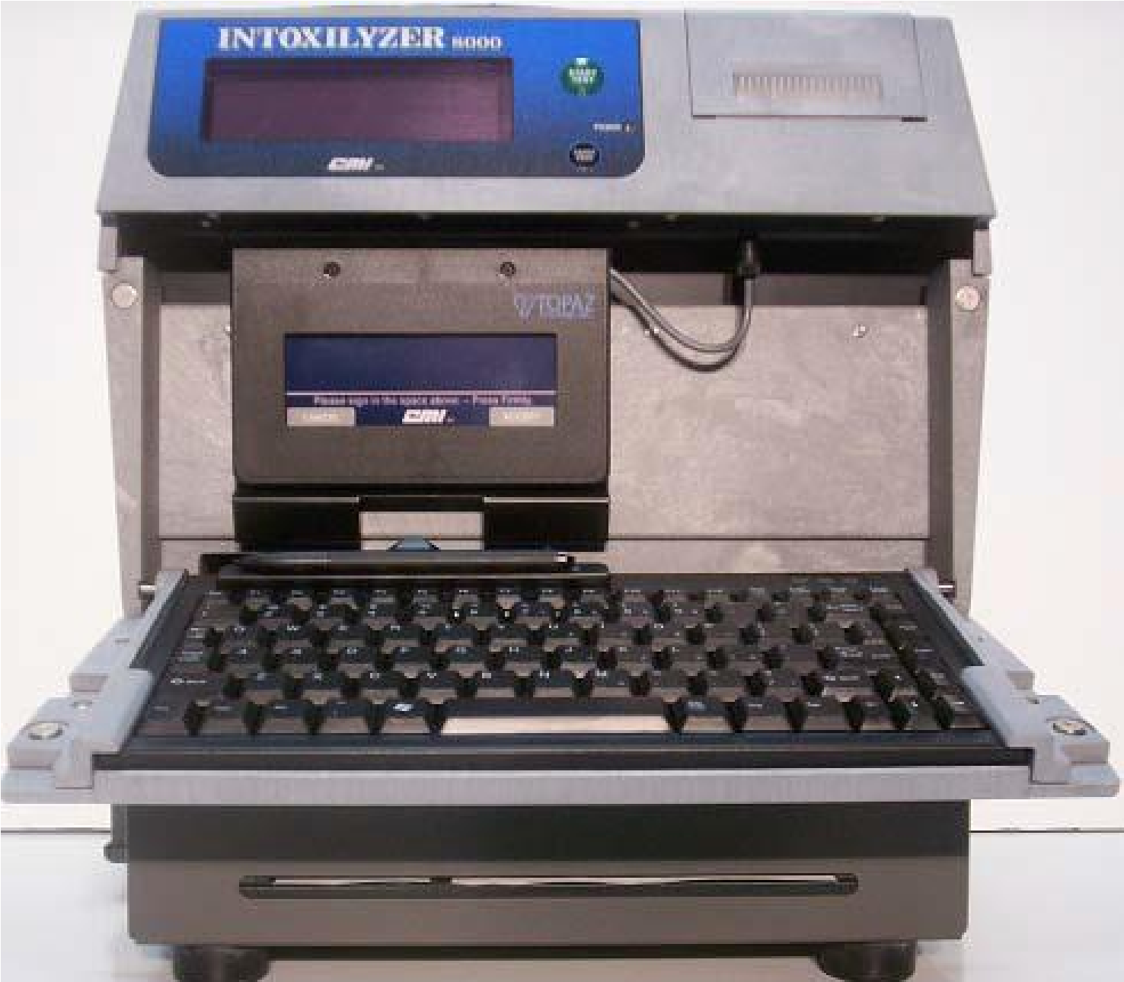

**2**

**-**

**D Bar Code**

**Reader**

**Signature**

**Pad**

**Styl**

**us**

**Keyboard**

**Thermal**

**Pape**

**r Slot**

**REAR VIEW**

**P**

**ower Switch 11**

**0**

**Volt AC**

**Power**

**Cord 11**

**0**

**Volt AC**

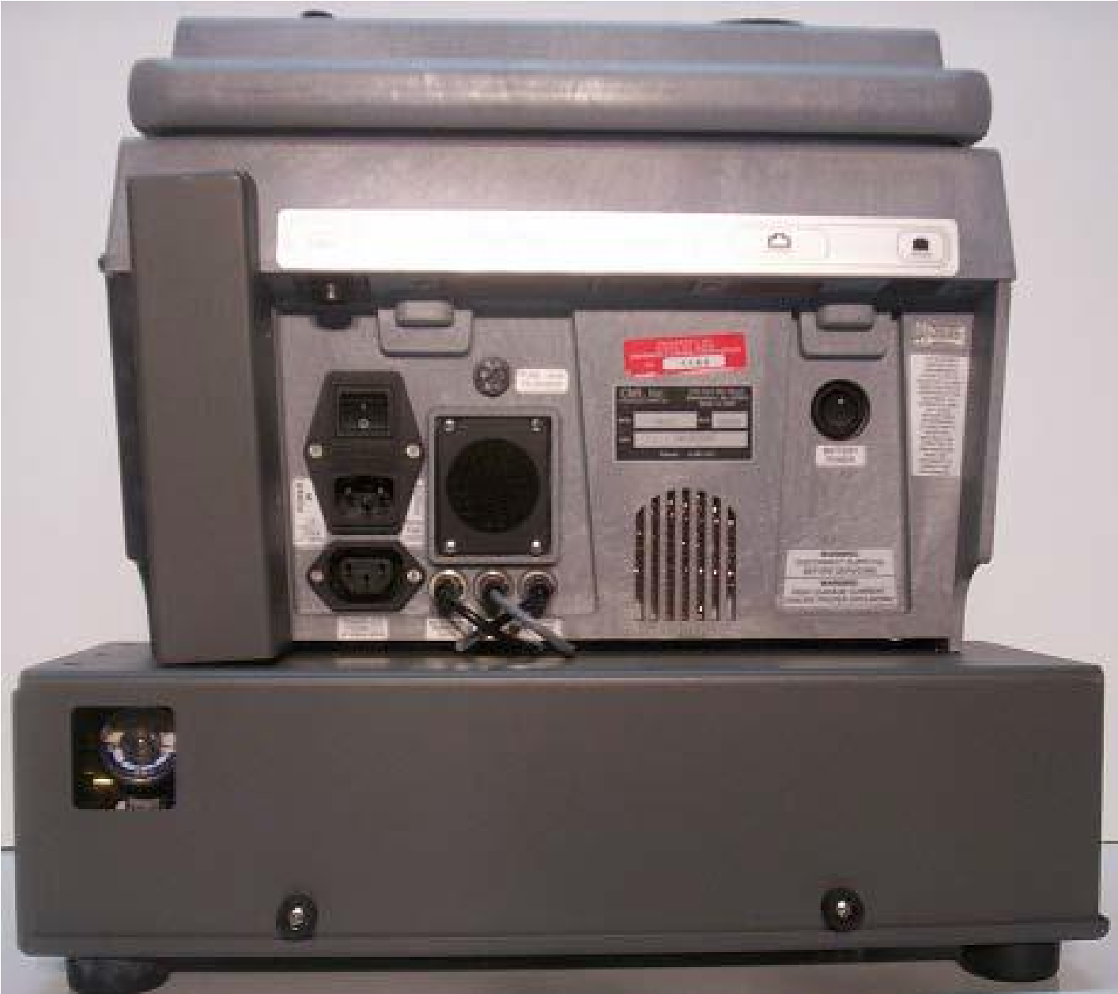

**Battery Power**

**Switch**

**Volt**

**(12**

**DC)**

**Instru**

**ment**

**Serial Number**

**Dry Ga**

**s**

**Stand**

**ard**

**Pr**

**es**

**sure Gauge**

**INTOXILYZER 8000**

**REAR VIEW**

**(BOTTOM)**

**Power Cord**

**Extern**

**al Printer**

**Ethernet**

**12**

**Volt DC**

**USB**

**Port**

**Connect**

**ion**

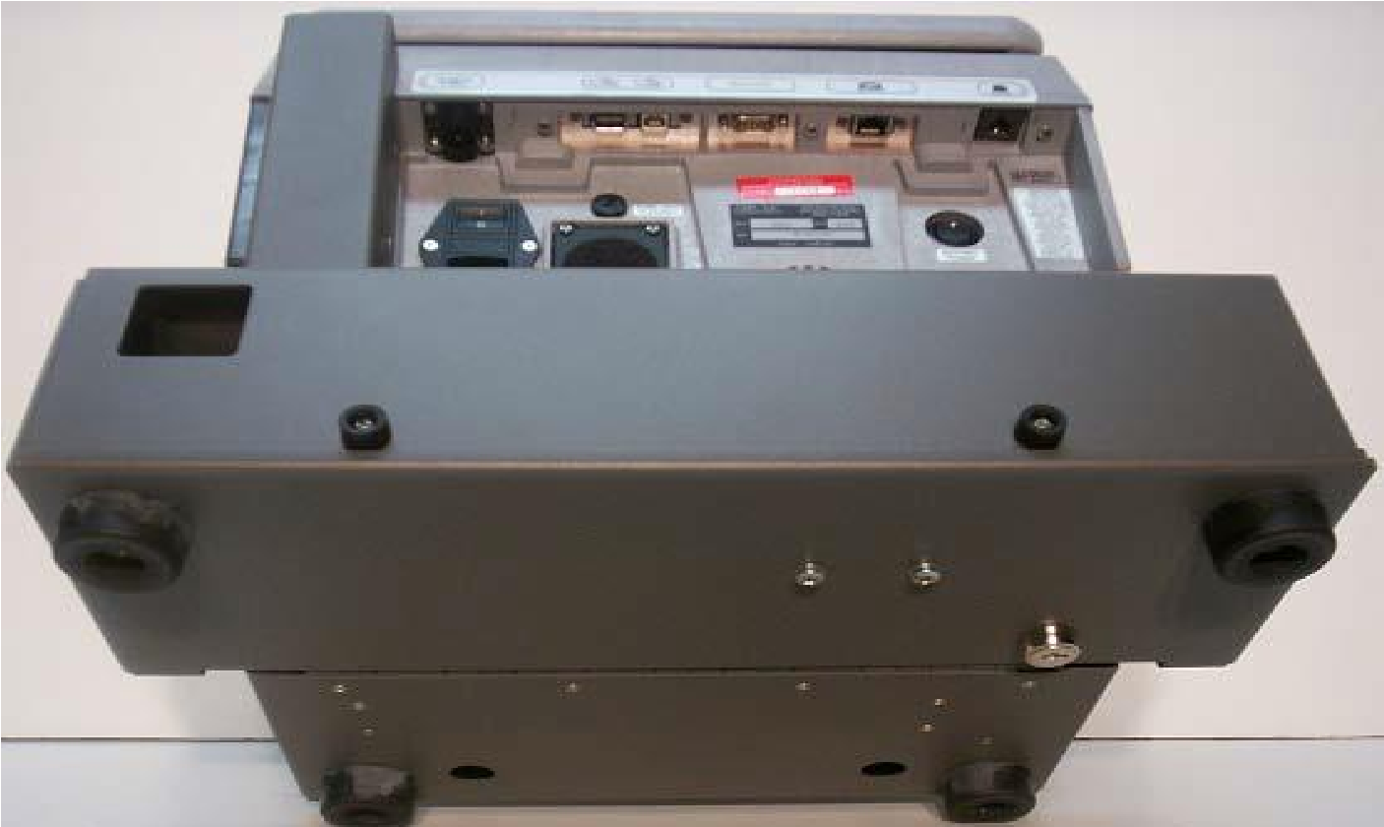

**Dry Ga**

**s Standa**

**r**

**d**

**Door Lock**

**TO**

**P**

**V**

**I**

**E**

**W**

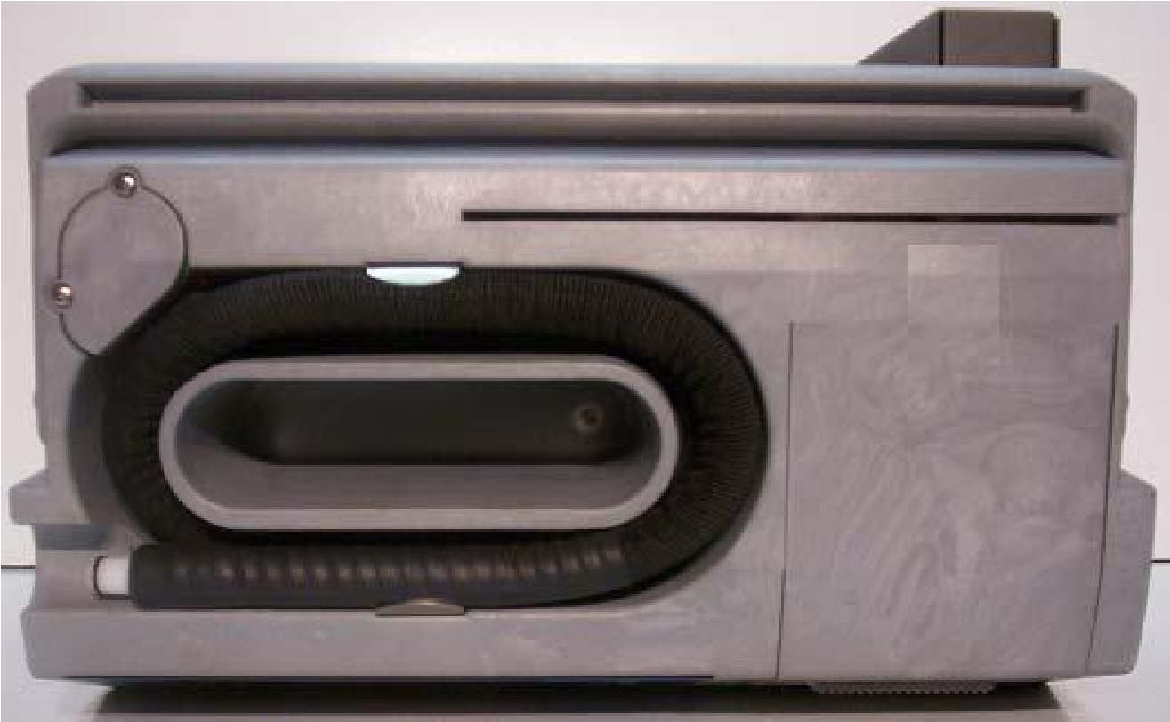

**Magnetic**

**Card**

**Sw**

**ipe**

**Li**

**cense/State ID**

**Breath Hose**

**(**

**Heat**

**ed)**

**SIDE VIEW**

**(CLOSED)**

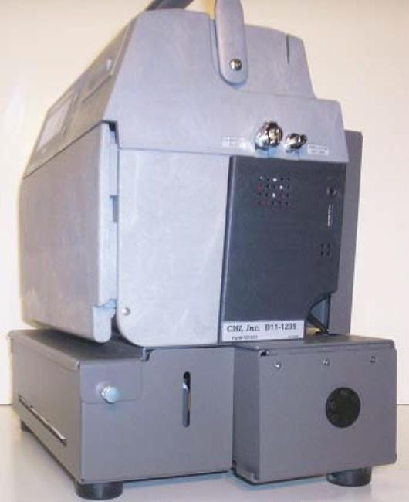

**Simulator**

**Certification**

**Ports**

**K**

**e**

**y**

**b**

**o**

**a**

**r**

**d**

**T**

**h**

**e**

**r**

**m**

**a**

**l**

**P**

**a**

**p**

**e**

**r**

**R**

**o**

**l**

**l**

**INTERNAL PRINTER**

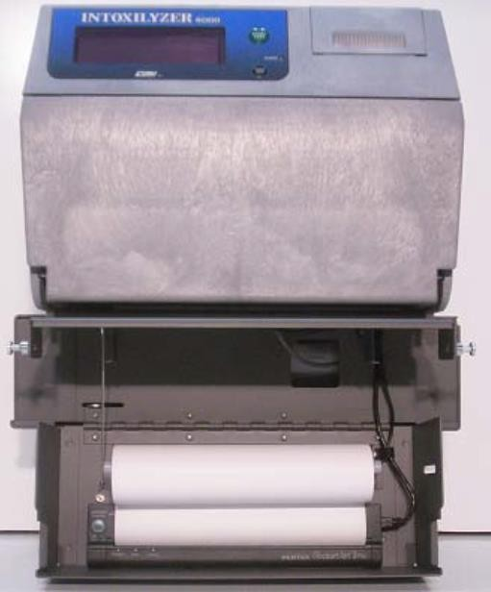

**Internal Printer**

**Door**

**Locks**

**I**

**nt**

**erna**

**l Printer Paper**

**Roll**

## SIGNATURE PAD

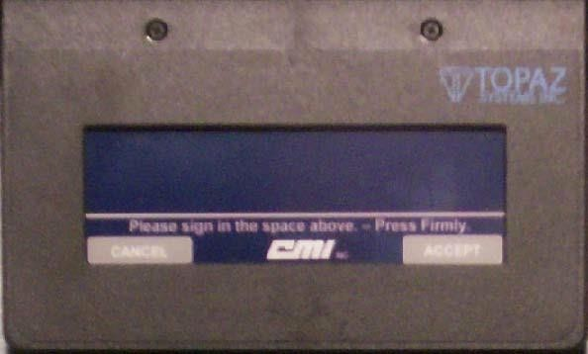

1. **DO NOT USE INK OR PENCIL ON THE SIGNATURE PAD.**

1. Use the attached **STYLUS** or an ink pen **WITH PEN TIP RETRACTED**.

1. **To complete a signature response press ACCEPT on the signature pad or ENTER on the keyboard.**

1. **To cancel a signature prior to pressing ACCEPT or ENTER,** **press CANCEL on the signature pad or ESCAPE on the keyboard.**

1. You may not make signature corrections after pressing **ACCEPT** or **ENTER**.

## KEYBOARD

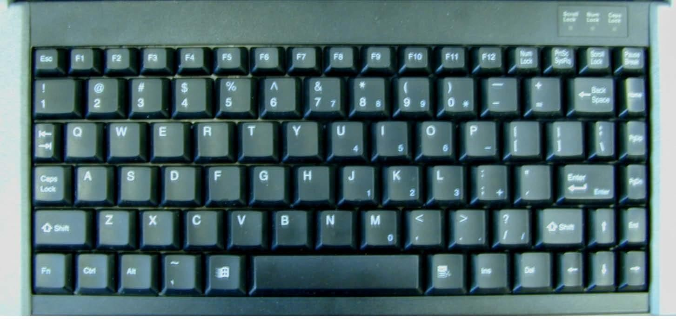

1. **To complete a response, press the** **ENTER key.**

1. **To scroll through the menus**, **press the arrow or or PgUp/PgDn keys.**

1. Correct mistakes prior to pressing **ENTER** or use the **BACKSPACE** key to erase one character at a time.

1. Make corrections after pressing **ENTER** by reviewing data.

1. Re-type the correct response.

1. The display will show a limited number of characters; however, all characters will be printed.

## 2-D BAR CODE READER

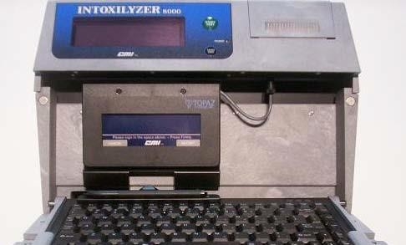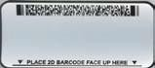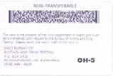

1. When “**PLEASE SWIPE / SCAN ACCESS CARD OR PRESS ENTER**” appears on the display, the **2-D BAR CODE** reader automatically activates.
2. Place your access card under the red light near the keyboard. Do not swipe the access card in operator license reader (top of instrument).
3. **A “three-beep tone” indicates the information has been entered. A “two-beep tone” indicates the information has not been entered.**
4. If the **2-D BAR CODE** fails to operate, press **ENTER** to manually enter the required data using the keyboard while following the instrument display.
5. The **2-D BAR CODE** reader is light sensitive. Use a flashlight to illuminate the access card in low light conditions.

### MAGNETIC STRIP READER OPERATOR’S LICENSE/STATE ID CARD

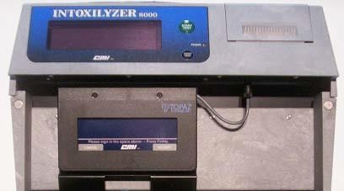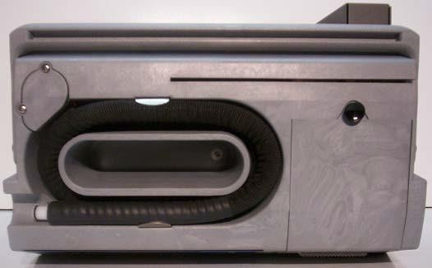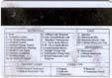

1. When “**PLEASE SWIPE / SCAN DL OR PRESS ENTER**” appears on the display, slide the violator operator’s license (DL) or state ID card through the magnetic card reader from left to right with the magnetic strip to the rear.
2. Slide the violator operator’s licenseor state IDcard **UPSIDE-DOWN** with license front **FACING YOU** from **LEFT** to **RIGHT** (magnetic strip upside down facing rear).
3. **A “three beep tone” indicates the information has been entered.**

**A “two-beep tone” indicates the information has not been entered.**

1. Press **ENTER** to manually enter the required data using the keyboard.

#### OPERATION

**INTOXILYZER 8000**

**THEORY OF OPERATION**

1. The Intoxilyzer 8000 uses the method of **INFRARED ABSORPTION** to analyze the breath sample.
2. The IR light source is a **PULSED INFRARED** light. Infrared light is not visible to the human eye. It is similar to the light from a TV channel changer.
3. The decrease in intensity of the IR light due to absorption by alcohol in the breath sample is proportional to the amount of alcohol in the breath.
4. **The breath sample hose is heated** **to prevent condensation**.

Sample chamber with air only

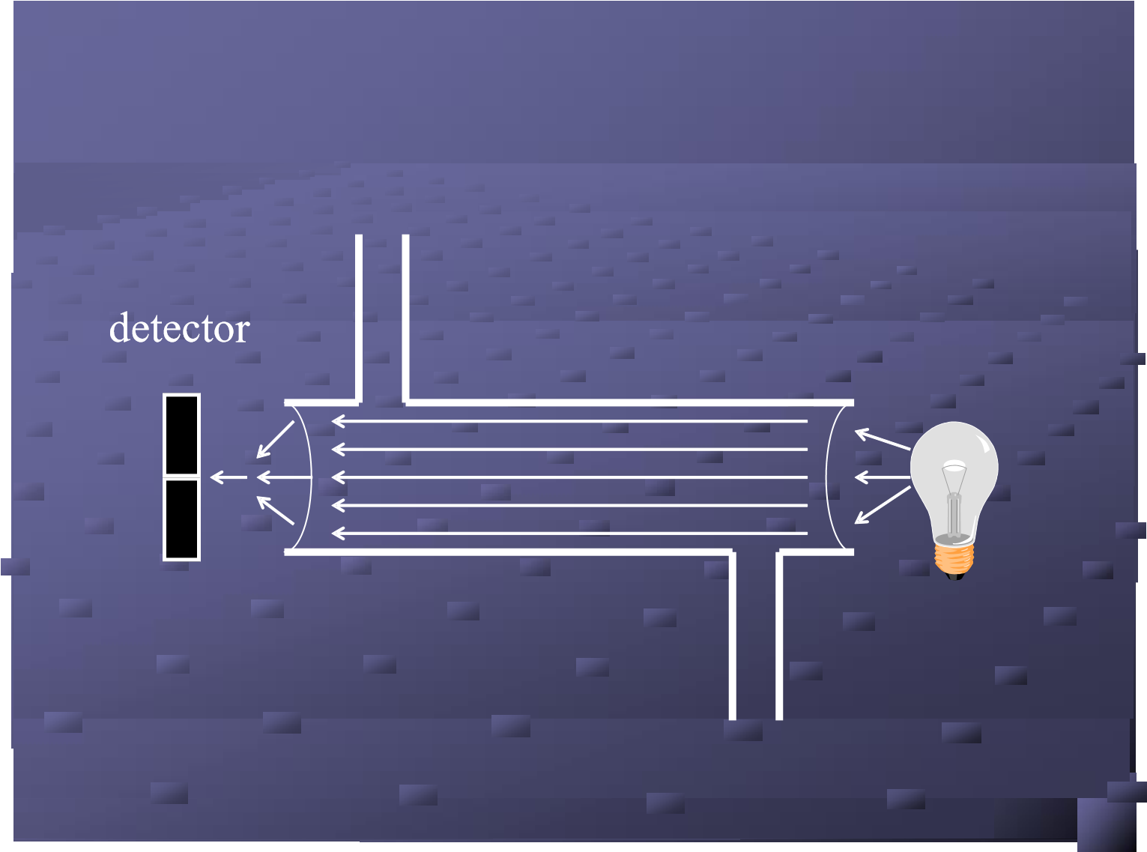

With air only in the sample chamber, all of the infrared light from the bulb reaches the detector on the far end of the chamber. There is no change in the intensity of the light.

Sample chamber with alcohol and air

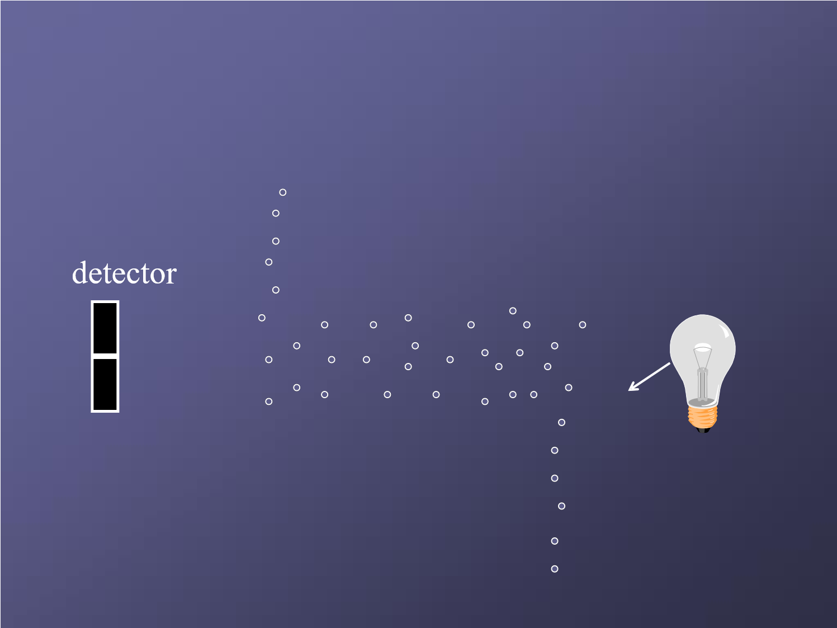

When alcohol is introduced into the sample chamber, some of the infrared light from the bulb is absorbed by the alcohol molecules. **The higher the alcohol concentration, the more light is absorbed, the higher the breath alcohol concentration reading (BrAC) on the instrument.**

### INTOXILYZER 8000 POWER UP

#### 110-VOLT AC POWER

**AC Power** is the **PRIMARY and default** power source for the Intoxilyzer 8000.

To power up the instrument using **AC POWER**, connect the **AC POWER CORD** to the instrument and insert the **110-VOLT POWER PLUG** into a 110-volt power source.

Move the **AC POWER SWITCH** and **BATTERY POWER SWITCH** to the **ON** position.

Press the **START TEST** button. The instrument will power up and enter **NOT READY** Mode.

#### 12-VOLT DC POWER

**DC Power** is a **SECONDARY** power source for the Intoxilyzer 8000.

To power up the instrument using **12-VOLT POWER**, the auxiliary power source should be started before connecting the **DC POWER CORD** to the instrument and inserting the **12-VOLT POWER TIP** into a 12-volt power source.

If you are going to use a DC power source, you should consult with Alcohol & Drug testing prior to use.

Move the **AC POWER SWITCH** and **BATTERY POWER SWITCH** to the **ON** position.

Press the **START TEST** button and the instrument will power up and enter **NOT READY** Mode.

### INTOXILYZER 8000

**INSTRUMENT DISPLAY**

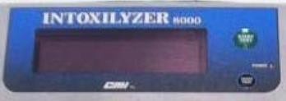

The instrument will display one of the following **CHARGING INDICATORS.**

The Intoxilyzer 8000 is in **NOT READY** Mode during the warmup period using **AC** or **DC** Power.



**Ch**

**arge Su**

**spend**

**%**

**55**

**Fast Charge 65%**

**Discharging 65%**

**Trickle Charge**

**%**

**95**

The Intoxilyzer 8000 is in **READY** or S**TANDBY** Mode using **AC** or **DC** Power.

The Intoxilyzer 8000 is in **READY** or **STANDBY** Mode using **INTERNAL BATTERY** Power.

The Intoxilyzer 8000 is in **READY** or

**STANDBY** Mode using **AC** or **DC**

Power. The battery is full charged.

**INSTRUMENT POWER LIGHT**

A green light indicates the Intoxilyzer 8000 is in **NOT READY**, **READY** or **STANDBY** Mode – Battery Charged.

**A**n amber light indicates the Intoxilyzer 8000 is in **NOT READY**, **READY** or **STANDBY** Mode – Battery Charging.

A red light indicates the Intoxilyzer 8000 is connected to an **AC** or **DC** power source but not powered up.

**TOTAL POWER OFF**

Move the **AC POWER SWITCH** and the **BATTERY POWER SWITCH** to the **OFF** position.

### INTOXILYZER 8000 NOT READY / READY / STANDBY / DIAGNOSTICS

#### NOT READY MODE

The instrument enters **NOT READY MODE** after power up displaying the date and time. The display will switch between **NOT READY** and **CHARGING STATUS**. After approximately 25 minutes, the instrument will beep and display the countdown to **READY MODE**.

#### STANDBY MODE

When not used for approximately **30 minutes** the instrument enters **STANDBY MODE**. The instrument will remain in **STANDBY MODE** until you press the **START TEST** button or power the instrument off.

Press the **START TEST** button and the instrument will beep and display the countdown to **READY MODE**. This takes approximately one minute.

#### DIAGNOSTICS

The instrument performs an **AIR BLANK** and **DIAGNOSTIC TEST** as part of the startup period. The instrument will cycle through each function and display **PASS** if functioning properly.

**Air blanks are performed periodically throughout the operation of the instrument to purge the sample chamber.**

If any of the diagnostics **FAIL**, restart by pressing the **START TEST** button. If this second diagnostic fails, **discontinue use, NOTIFY ADT AT (614) 644-4678 and forward an Event Report**.

**If any function does not perform, including but not limited to 2-D Bar Code reader, signature pad, print locks (does not print record), turn both switches off, wait momentarily, then turn both switches back on and press the START TEST button** (see also the page on data downloads).

### INTOXILYZER 8000 DATA ENTRY

**To initiate a subject test sequence, press the START TEST button.**

**When responses are displayed, they are the default responses**.

|  |
| --- |
| **Swipe/Scan Access Card or Press Enter** |

Place **OPERATOR ACCESS CARD** under the red light near the keyboard. The **2-D BAR CODE** reader is light sensitive. You may use a flashlight to illuminate the access card in low light conditions.

|  |
| --- |
| **Enter 4-Digit Pin #** |

Type in your **4-DIGIT PIN NUMBER**.

Press **ENTER** to continue. If PIN is incorrect, the I-8000 will display **INCORRECT PIN** and sound a **High/Low tone**.

VERIFY all the information as the prompts are displayed. If the prompt information is correct, press **ENTER** to continue. If the prompt information is incorrect, correct manually using the keyboard, then press **ENTER** to continue.

If you have issues with the access card and/or if the information on the card is incorrect, contact the Alcohol & Drug Testing Program at (614) 644-4609.

|  |
| --- |
| **Operator’s Last Name?** |

Your **LAST NAME** from the Operator access card appears on the display. Press **ENTER**, if correct, to continue.

|  |
| --- |
| **Operator’s First Name?** |

Your **FIRST NAME** from the Operator access card appears on the display. Press **ENTER**, if correct, to continue.

|  |
| --- |
| **Operator’s Agency?** |

Your **AGENCY** from the Operator access card appears on the display. Press **ENTER**, if correct, to continue.

|  |
| --- |
| **Time First Observed?** |

Use **24-HOUR** format **00:00.** Press **ENTER** to continue.

**Time First Observed** **MUST** be twenty minutes or more prior to the first breath sample.

|  |
| --- |
| **Swipe/Scan Access Card or Press Enter** |

If the **ARRESTING OFFICER** has an **OPERATOR**

**ACCESS CARD,** place the **ARRESTING OFFICER’S OPERATOR ACCESS CARD** under

the red light near the keyboard

If the **ARRESTING OFFICER** does not have an **OPERATOR ACCESS CARD**, press **ENTER** to manually enter the required data using the keyboard following the instrument display.

|  |
| --- |
| **Review Data (Y/N)**  **N** |

The “**N**” (No) response is displayed. Press **ENTER** to skip **REVIEW DATA**. Press “**Y**” (Yes) to **REVIEW** the information. Press **ENTER** to verify each entry. Press “**N**” (No) followed by **ENTER** to continue.

**TESTING SEQUENCE / SUBJECT TEST**

The **SUBJECT’S LAST NAME** is displayed as it appears on the operator’s license or state ID card or type the **SUBJECT’S LAST NAME** using the keyboard.

Press **ENTER** to continue.

The **SUBJECT’S FIRST NAME** is displayed as it appears on the operator’s license or state ID card or type the **SUBJECT’S FIRST NAME** using the keyboard.

Press **ENTER** to continue.

The **SUBJECT’S STREET ADDRESS** is displayed as it appears on the operator’s license or state ID card or type the **SUBJECT’S STREET ADDRESS** using the keyboard. Press **ENTER** to continue.

The **SUBJECT’S CITY** is displayed as it appears on the operator’s license or state ID card or type the

**SUBJECT’S CITY** using the keyboard. Press **ENTER** to continue.

|  |
| --- |
| **Subject’s State? OH**  **OHIO** |
| **Subject’s Zip Code** |
| **Subject’s Date of Birth** |

The **SUBJECT’S STATE** is displayed as it appears on the operator’s license or state ID card. The display defaults to **“OH”**. If the state differs, type the two letter **SUBJECT’S STATE** abbreviation or scroll through the menu to select the correct state. Press **ENTER** to continue.

The **SUBJECT’S ZIP CODE** is displayed*.*

If the zip code differs, type the correct zip code. Press **ENTER** to continue.

The **SUBJECT’S DATE OF BIRTH** is displayed as

it appears on the operator’s license or state ID card or type the **SUBJECT’S DATE OF BIRTH** using the keyboard. The format is MM/DD/YYYY. Press **ENTER** to continue.

|  |
| --- |
| **Subject’s Age** |

The instrument will display the **SUBJECT’S AGE.** The instrument automatically forwards to the next display field after a few moments.

|  |
| --- |
| **Subject’s Sex? M**  **Male** |

The **SUBJECT’S SEX** is displayed.

The prompt defaults to **“M”**. Enter the correct gender.

Press **ENTER** to continue.

|  |
| --- |
| **Subject’s Race? W**  **White** |

The **SUBJECT’S RACE** is displayed. The prompt defaults to **“W”**. Enter race format (A=Asian, B=Black, H=Hispanic, N=Native American, O=Other, W=White) or scroll through the menu. Press **ENTER** to continue.

|  |
| --- |
| **Review Data (Y/N)?**  **N** |

**REVIEW DATA (Y/N)** is displayed.

The display defaults to “**N**” (No). Press **ENTER** to skip **REVIEW DATA**. Press “**Y**” (Yes) to **REVIEW** the information. Press **ENTER** to verify each entry.

|  |
| --- |
| **Operator**  **Please Sign on Attached Pad** |

The **OPERATOR** signs on the **SIGNATURE PAD.** Press **ACCEPT** on the signature pad or press **ENTER.**

**At any time during the breath sample, when Please Blow /R appears, the operator can press R and enter as a refusal.**

|  |
| --- |
| **Review Data (Y/N)?**  **N** |

The “**N**” (No) response is displayed.

Press **ENTER** to skip **REVIEW DATA**.

Press “**Y**” (Yes) to **REVIEW** the information. Press **ENTER** to verify each entry.

The instrument will perform an air blank, a diagnostic test, an air blank, reference, a dry gas control (results must be +/- 0.005 of the target value), and an air blank.

|  |
| --- |
| **Reference** |
| **Please Install Mouthpiece Press Any Key to Proceed** |

The instrument will conduct a reference. **DO**

**NOT ALLOW** a breath sample to be provided at this time.

Place a **MOUTHPIECE** on the breath tube

|  |
| --- |
| **Please Blow Until Tone Stops /R** |
| **Please Remove Mouthpiece Press Any Key to Proceed** |

**ADVISE THE SUBJECT TO PROVIDE A**

**BREATH SAMPLE. THE SUBJECT SHOULD**

|  |
| --- |
| **Please Wait Ready in 02:00** |
| **Please Install Mouthpiece Press Any Key to Proceed** |
| **Please Blow Until Tone Stops /R** |

**NOT QUIT UNTIL ALL BREATH IS EXHAUSTED.** The subject has **3 minutes** to obtain a breath sample.

#### DISCARD THE MOUTHPIECE

Press any key to Proceed.

The two-minute **COUNTDOWN** will be displayed.

Place a new **MOUTHPIECE** on the breath tube for the second subject sample

**ADVISE THE SUBJECT TO PROVIDE A SECOND BREATH SAMPLE. THE SUBJECT SHOULD NOT QUIT UNTIL ALL BREATH IS EXHAUSTED.**

**At any time during the breath sample, when Please Blow /R appears, advise the subject to continue to provide a sample. The operator can also press R and enter as a refusal**

|  |
| --- |
| **Please Remove Mouthpiece Press Any Key to Proceed** |

**DISCARD THE MOUTHPIECE** Press any key to proceed.

The instrument will perform an air blank, reference, a dry gas control (results must be +/- 0.005 from the target value), and an air blank.

|  |
| --- |
| **Printing Form**  **………………………….** |

The instrument continues until the test is complete.

**Printing of Subject Test Report begins.**

|  |
| --- |
| **Ready Mode**  **09/17/2019 09:40** |

The instrument returns to “Ready Mode”.

This is a complete subject test form. There will be a dry gas control before the first breath sample and after the last breath sample. There must be two complete breath samples for the breath test. **The BrAC reading on the report will be the lower of the two sample readings.**

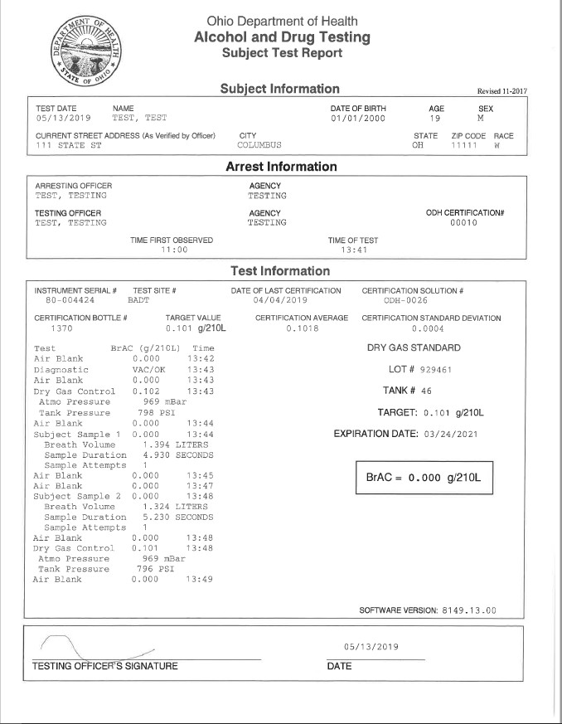

#### SUBJECT TEST REPORT FORM

**The form that prints from the I-8000 has the same information that is posted on the ODH website.**

**Atmo Pressure:** atmospheric pressure is measured in millibars (mBar). Pressure is measured as part of the instrument’s internal checks.

**Tank Pressure:** tank pressure is measured in pounds per square inch (PSI) and reflects the amount of gas left in the cylinder. It has no effect on the subject test.

**Breath Volume:** The volume of the breath sample (measured in liters) is recorded. The subject must provide a minimum sample for the breath sample to be measured.

**Sample Duration:** The instrument records the length of time the subject provides a complete breath sample.

**Sample Attempts:** If the subject does not provide a continuous breath sample, the instrument will record this as an attempt. The subject must provide a continuous sample to be measured.

#### ESCAPE SEQUENCES INTOXILYZER 8000

|  |
| --- |
| **Swipe/Scan Certification Card or Press Enter** |

Pressing the escape key twice on the keyboard will **DISPLAY** the following:

Place **OPERATOR ACCESS CARD** under the red light near the keyboard or press **ENTER** to manually enter the access card number. Enter your **PIN** number when requested.

Use the or **ARROW** keys to move the **1: ADPRSQT** cursor or press the **LETTER KEY** to go directly to **Continuous Air Blank** that function.

Press “**A**” followed by **ENTER** to perform a **1: ADPRSQT CONTINUOUS AIR BLANK.** The instrument pump **Continuous Air Blank** will **PURGE** the sample cell. Press the **START TEST** button to stop the **CONTINUOUS AIR BLANK**.The **DISPLAY** automatically returns to the menu.

**Press “D” followed by ENTER to perform and 1: ADPRSQT print a DIAGNOSTIC TEST**.The **DISPLAY Diagnostic** automatically returns to the menu.

Press “**P**” followed by **ENTER** to perform a **PRINT 1: ADPRSQT TEST.** The **DISPLAY** automatically returns to the **Print Test** menu.

Press “**R**” followed by **ENTER** to **RECALL** prior **1: ADPRSQT** subject test records from memory. **Recall Test From Mem**

The most recent **RECORD DATE** will be displayed. **Record Date**

Press the **PgUp/PgDn** keys to scroll through dates. **10/15/2013** Once the correct **RECORD DATE** appears, press **ENTER.**

The number of **RECORDS** will be displayed for that **10/15/2013**

date. Press **ENTER** to continue. **# OF RECORDS: 003**

Use the or **ARROW** keys to display each **10/15/2013 R#: 001** RECORD. Use the or **ARROW** keys **#DOE, JOHN**  to view additional information to confirm the record. Press **ENTER** to **PRINT** the displayed record. Press the **ESCAPE** key until the **DISPLAY** returns to the menu.

**Press “S” to REPRINT LAST TEST** then press **1: ADPRSQT ENTER.** **Reprint Last Test**

Press “**Q**” followed by **ENTER** to return the **1: ADPRSQT**

instrument to **READY MODE**. **Quit Menu**

Press “**T**” followed by **ENTER** to test **SIGNATURE 1: ADPRSQT PAD**. **Sig Pad Test**

The instrument returns to Ready Mode. **Ready Mode**

**Push Any Button to Start**

#### EXCEPTION MESSAGES

##### INTOXILYZER 8000

A message may be displayed to the operator indicating an exception has been identified. The following chart includes the exception messages displayed, the issue identified by the instrument and the operator’s best practices to complete a valid testing sequence. Whenever a new testing sequence is initiated, the operator should reinstruct the subject on how to successfully complete a test sequence, utilize a new mouthpiece and use discretion when determining if a new observation period should be performed.

Four signs of a Terminated Test:

1. The test aborts.
2. The instrument sounds a High/Low tone.
3. The exception message displays.
4. The exception message is printed.

|  |  |  |
| --- | --- | --- |
| Exception Displayed | Issue | Best Practice |
| **Ambient Fail** | Ethanol was detected in the  air brought into the instrument during an air blank. | **Check area around instrument for a possible source of ethanol and make best effort to remove source and/or ventilate area.**  **Retest subject**. |
| **Deficient Sample** | The subject does not provide an adequate sample during the required three-minute time frame. | **Retest subject.** |
| **Diagnostic Fail** | The instrument did not successfully complete an internal diagnostic check. The test record will identify and print the specific diagnostic failure. | **Retest subject.**  Contact ADT (see below) if second sequence is unsuccessful. |
| **Dry Gas Out of Tolerance** | The dry gas control value generated is outside of required limits. If the result is out of tolerance low, generally, the issue is environmental. | **Retest subject.**  Contact ADT (see below) if second sequence is unsuccessful. If the result is low, remove possible sources of ethanol from the area and **retest subject.** |
| **Improper Sample** | The subject provided a breath sample at the wrong time in the sequence. | **Retest subject.** |

|  |  |  |
| --- | --- | --- |
| **Input Timeout** | The data entry function timed-out waiting for input from the operator. | **Retest subject.** |
| **Interferent Detect** | A substance other than alcohol was detected in the breath sample. | **Retest subject.**  Request a blood or urine sample if second sequence is unsuccessful. |
| **Invalid Sample** | Possible mouth alcohol was detected in the subject’s sample. | **Retest subject**. |
| **No Sample Given** | The subject did not provide a breath sample. | **Retest subject.**  Request a blood or urine sample if second sequence is unsuccessful. |
| **No 0.020 agreement** | The subject test results were not within 0.020 g/210L of each other. | **Retest subject.** |
| **Purge Fail** | The air blank after an analytical reading was not adequately cleared within required limits. | **Retest subject.**  Contact ADT (see below) if second sequence is unsuccessful. |
| **Range Exceeded** | The analytical value exceeds the maximum reported value of the instrument. | **Retest subject.**  Contact ADT (see below) if second sequence is unsuccessful. |
| **RFI Detect** | Radio Frequency Interference has been detected. | **Check area around instrument for a possible source of radio frequency and make best effort to remove source from the area.**  **Retest subject.** |
| **Sequence Aborted** | The Start Test button was pressed during an ongoing test sequence. | **Retest subject.** |
| **Tank Pressure Low** | Dry Gas Control pressure is below 50 PSI. | Complete testing sequence and **contact ADT** (see below). |
| **Tank Pressure Below**  **Minimum – Shutting**  **Down** | Dry Gas Control pressure is below 25 PSI. | Use a different instrument or method of obtaining a sample.  **Contact ADT** (see below). |

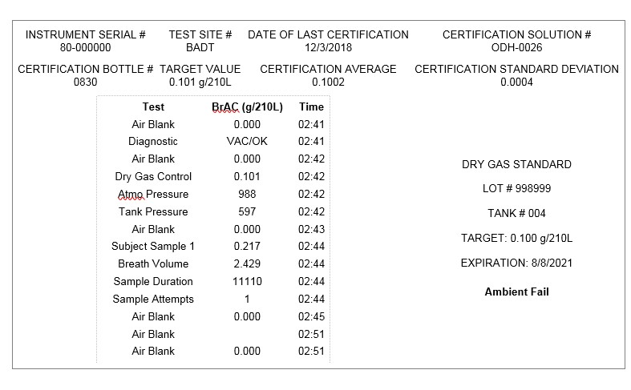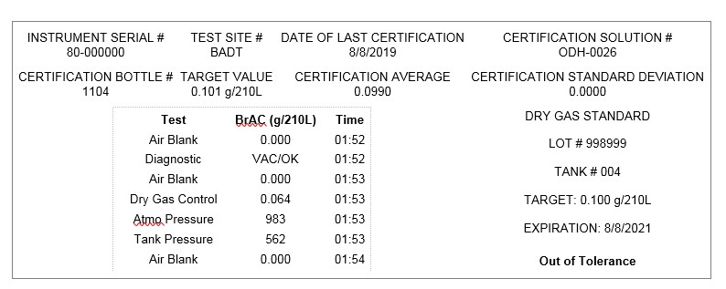

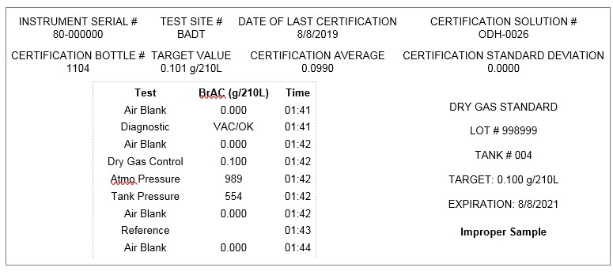

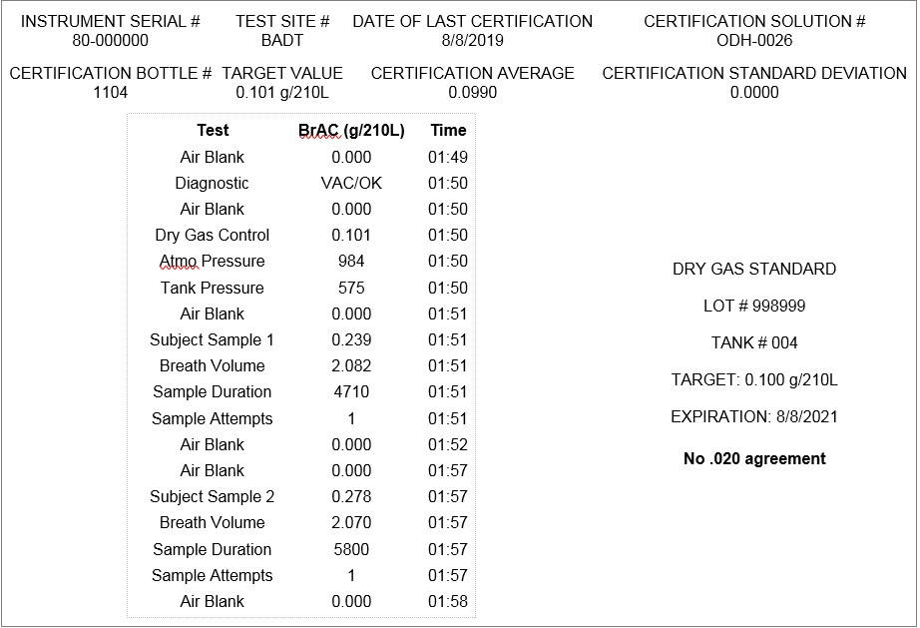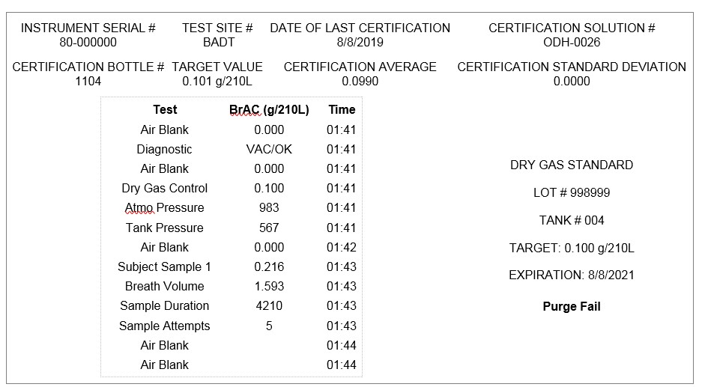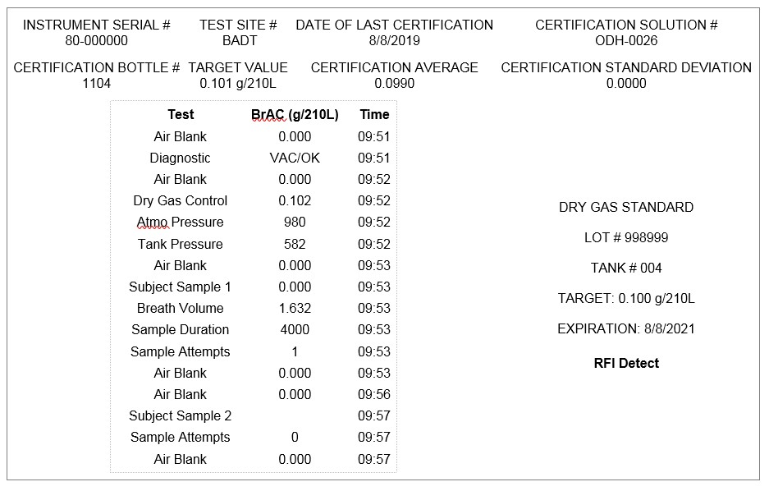

Ohio Department of Health

Alcohol & Drug Testing Program

Phone (614) 644-4609

Fax (614) 279-9179

**EVENT REPORT**

**Use this form to report any issues with the instrument.**

**The form is available in a document file for agencies to download for their own use.**

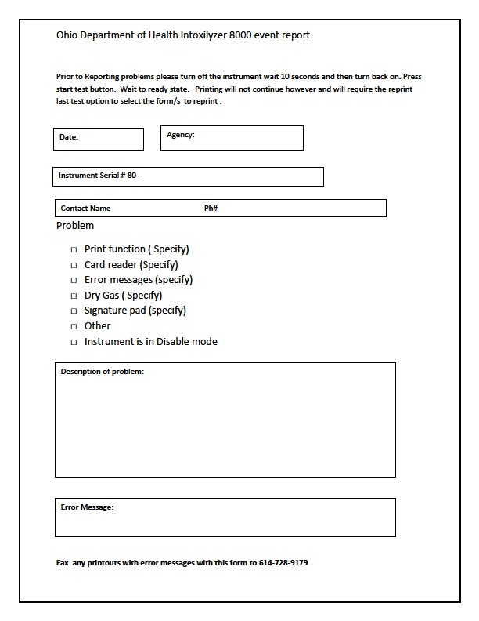

#### INTOXILYZER 8000

**LASER JET PRINTER STATIONARY APPLICATION**

The internal Pentax thermal printer is the default printer for the instrument.

When the instrument is used inside the station or when returned to the station after portable use, connect the instrument to the Brother Laser Jet printer with the USB cable.

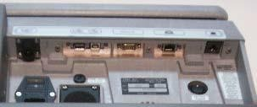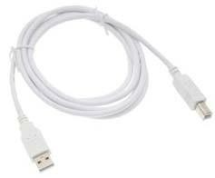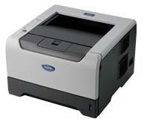

Turn the Laser Jet power switch to the ON position. The USB connection automatically sends all printing to the Laser Jet printer when connected to the instrument.

A flashing yellow toner light indicates the toner needs to be replaced soon. Toner can be obtained from a local vendor.

To return to the internal Pentax thermal printer for portable use, disconnect the laser jet USB cable from the instrument. The instrument is now ready for portable use. The internal Pentax thermal printer is automatically ready for printing.

It is recommended that the Laser Jet printer remains connected unless the instrument is removed for portable use.

**INTOXILYZER 8000**

**DATA TRANSFER / INSTRUMENT UPDATES**

To transfer data from the Intoxilyzer 8000 and receive instrument updates:

1. Turn **both** power switches off, wait momentarily, then turn both switches back on and press the **START TEST** button.
2. **NOT READY MODE** appears on the display.
3. Press and hold the “**CTRL**” and the “**U**” keys at the same time.
4. The instrument will automatically connect to the server.
5. While **DOWNLOADING** the following appears on the instrument display: **DO NOT TURN POWER OFF UNTIL TRANSFER IS COMPLETE**

|  |  |  |
| --- | --- | --- |
| **Comms Transfer**  **Connecting …………………..** |  | **Comms Transfer**  **Connected …………………..** |
| **Comms Transfer Comms Session Active………..** |  | **Comms Transfer Records**  **Downloading………..** |

**Operator.dat file Uploading ……………….**

1. When **DOWNLOAD** is successful the following appears on the instrument display:

**Comms Transfer Upload: OK**

1. Press any key on the keyboard and the instrument display returns to normal.

**Ready Mode**

**Push Any Button To Start**

If **DOWNLOAD** is **UNSUCCESSFUL**, the following appears on the instrument display:

**No Connect Retry? Y/N**

Press Y. If the retry fails, the following appears on the display:

**Comms: Transfer**

**Upload Fail**

**IF A SECOND “CTRL” “U” FAILS -**

**FORWARD AN EVENT REPORT VIA FAX.**

**NOTIFY ADT AT (614) 644-4609**

**LEAVE MESSAGE IF NO ANSWER.**

**PLEASE GIVE AGENCY NAME,**

**INSTRUMENT SERIAL NUMBER, AND ADVISE**

**COMMUNICATION TRANSFER FAILED Press Any Key To Continue Subject Testing**

#### Annual Access Card Proficiency

In order to maintain a valid access card, the card holder must perform either a complete, successful violator (subject) test with a breath alcohol concentration (refusals, time outs, or other incomplete tests do not qualify) OR a complete, successful proficiency test, following guidelines provided by the Alcohol & Drug Testing Program at least once each calendar year (Jan. 1 through Dec. 31). If a complete subject test or proficiency test is not provided, the access card holder is subject to revocation. Refer to Ohio Administrative Code Rules 3701-53-08 (D), 3701-53-09 (E), and 3701-5310 (B) and (C)(2).

If you do not complete a successful proficiency or subject test in a calendar year, your card will be inactivated. You will need to pass a written test and proficiency test WITH an inspector in order to be reactivated.